**Supplementary Information**

## S1. The BEMTOOL modelling platform

BEMTOOL is a software platform for bio-economic modelling, that allows simulating the effects of management measures and/or harvesting strategies on the dynamics of exploited stocks in the short, medium and long term. Considering that the management of Mediterranean fisheries is generally based upon input control systems (e.g. fishing effort limitation, mesh size restriction, closed season), the platform is focused on the implementation of these measures, but options for TAC implementation are also available.

The BEMTOOL platform consists of a core model, describing the dynamics of a single population, and a number of modules, interconnected to the core model through a suite of functions. The platform includes the following 5 operational modules:

* biological, which simulates the dynamics of biomass and demographic structure of each stock affected by the fishing activity;
* pressure, which simulates the effect of fishing mortality and the consequent production (landings and discards), possibly disaggregated by fleet segment and/or metier;
* economic, which simulates the dynamics of the economic variables characterizing the fishery;
* behavioural, which simulates the dynamic transformation of the profit obtained from fishing into fishing effort. This is achieved via an appropriate description of fishermen's behaviour (investment and disinvestment), including fleet dynamics like entity-exit decisions of fishing vessels and changes due to technological progress;
* policy, whose core features are the harvest rules that simulate the implementation of a specific management measure or a set of management measures, as well as the application of taxes and subsidies, all of which directly or indirectly affect the economic and biological processes.

The BEMTOOL platform has been designed to integrate a wide suite of already existing tools for stock assessment and biological and bio-economic modelling, which are currently used by STECF and GFCM Mediterranean stock assessment working groups. The platform makes thus available a number of alternative technical solutions for each module, allowing the user to choose the most suitable combination of models on the basis of the features of the fisheries under investigation and the available data. The resulting platform provides a highly flexible tool able to describe different fisheries and management options, which is also open to future updates to integrate other modelling tools as long as they will be made available.

The biological and pressure models currently integrated into the platform include:

* ALADYM (Age-Length bAsed DYnamic Model),
* SURBA (Survey Based Assessment),
* VIT,
* XSA (eXtended Survivor Analysis),
* FLR scripts for short and medium term forecast developed during the SGMED working groups 2010-2011,

while the functions for the economic assessment are based on the following models:

* BIRDMOD,
* MEFISTO,
* FISHRENT,
* IAM,
* BEMMFISH.

To assess the performances of management options under scrutiny from a multi-dimensional perspective, BEMTOOL provides also a module for running multi-criteria decision analyses based on MAUT and AHP algorithms.

In this work, we used the outputs of BEMTOOL simulations performed in the framework of the MAREA project (http://mareaproject.net/) with the aim to assess the status of Mediterranean fisheries. In particular, we used those relevant to GSA 18 (Southern Adriatic Sea), with particular focus on the demersal fishery taking place along the western (Italian) side of the area. Five DCF fleet segments (EC 2008, 2010; see also http://datacollection.jrc.ec.europa.eu/wordef/fleet-segment-dcf) were considered: demersal trawlers/seiners (DTS) from 06 to 18 m (grouping the VL0612 and VL1218 fleet segments), DTS from 18 to 24 m, DTS from 24 to 40 m, vessels using hooks (HOK) from 12 to 18 m, and vessels using polyvalent passive gears only (PGP) to 12 m (VL0012). Considered stocks were those of the four most important target species, namely *Mullus barbatus*, *Merluccius merluccius*, *Nephrops norvegicus* and *Parapenaeus longirostris*. Fleet segments involved in the fishery were selected on the basis of the DCF EU fishing fleet landings data by species and fleet segment level included in the Joint Research Center (JRC) database (STECF 2013a, 2013b). Data for the estimation of economic parameters were collected from the JRC database and from the data bank of the Italian Ministry of Agricultural, Food and Forestry Policies (http://www.politicheagricole.it). Biological parameters were derived from recent stock assessments (STECF 2012, STECF 2013a). BEMTOOL was run using the BIRDMOD module (Accadia and Spagnolo 2006) for the socioeconomic component and the ALADYM module (Lembo et al. 2009; Spedicato et al. 2010) for the biological one. BEMTOOL outputs used for the multi-criteria analysis described in the present paper included a set of biological, pressure and economic indicators, describing the evolution and state of the main targeted stocks, the level and pattern of fishing pressure on the stock and the economic performance of the fisheries under different management scenarios (as thoroughly described in the main text).

## S1.1 Supplementary references

Accadia P, Spagnolo M. A bio-economic simulation model for the Italian fisheries. Proceedings of the Thirteenth Biennial Conference of the International Institute of Fisheries Economics & Trade (IIFET), July 11-14, 2006, Portsmouth, UK. Corvallis, Oregon: The International Institute of Fisheries Economics & Trade; 2006.

EC. Commission Regulation (EC) No 665/2008 of 14 July 2008 laying down detailed rules for the application of Council Regulation (EC) No 199/2008 concerning the establishment of a Community framework for the collection, management and use of data in the fisheries sector and support for scientific advice regarding the Common Fisheries Policy. Official Journal of the European Union L 186:3-5; 2008.

EC. Commission Decision of 18 December 2009 adopting a multiannual Community programme for the collection, management and use of data in the fisheries sector for the period 2011-2013. Official Journal of the European Union L 41:8-71; 2010.

Lembo G, Abella A, Fiorentino F, Martino S, Spedicato M-T. ALADYM: an age and length-based single species simulator for exploring alternative management strategies. Aquatic Living Resources 2009;22:233–41.

STECF. Report of the Scientific, Technical and Economic Committee for Fisheries on Assessment of Mediterranean Sea stocks – part 1 (STECF 12-19). Luxembourg: Publications Office of the European Union; 2012.

STECF. Report of the Scientific, Technical and Economic Committee for Fisheries (STECF). 2013a Assessment of Mediterranean Sea stocks part I (STECF 13-22). Luxembourg: Publications Office of the European Union; 2013.

STECF. Report of the Scientific, Technical and Economic Committee for Fisheries (STECF). 2013b Assessment of Mediterranean Sea stocks part II (STECF-14-18). Luxembourg: Publications Office of the European Union; 2013.

**S2. Questionnaires for the Analytic Hierarchy Process**

**Instructions**

In the Analytic Hierarchy Process, the importance of each indicator (attribute) with respect to the others in addressing/representing a specific management objective is assessed through pair-wise comparisons among attributes. Comparisons are performed between attributes belonging to the same hierarchical level and for each level of the hierarchical tree. The results of the pair-wise comparison are then used to compute the weights expressing the relative importance of the attributes. The following scale has been adopted to evaluate the relative importance of one attribute over the others:

**LLL** extremely less important

**LL** less important

**L** moderately less important

**E** equally important

**M** moderately more important

**MM** more important

**MMM** extremely more important

Pair-wise comparisons are presented in a matrix form, in which the attributes in the rows are compared against the attributes in the columns. In practice, only the upper triangular matrix needs to be filled in:

|  |  |  |  |
| --- | --- | --- | --- |
|  | Attribute 2 | Attribute 3 | Attribute 4 |
| Attribute 1 |  |  |  |
| Attribute 2 |  |  |  |
| Attribute 3 |  |  |  |

Each ‘bold’ cell should be filled with one of 7 evaluations: LLL, LL, L, E, M, MM, MMM.

As an explicative example, let’s consider the main objective ‘Social sustainability’. We want to assess if, keeping in mind the overall goal of maximizing social utility, the level of employment in the fishery sector is equally important or not than fishermen’s wage.

|  |  |
| --- | --- |
|  | Average crew remuneration |
| Employment |  |

If you feel that employment is equally important than wage as an indicator of social sustainability, you should write ‘**E**’ in the matrix above. Instead, if you feel that the level of employment is more critical than the average remuneration in determining the social utility, you should write ‘**M’**, ‘**MM’** or **‘MMM’** depending on your beliefs about the intensity of the preference.

*Remember!! Read the matrix from left to right: the attribute in the row is evaluated against the attribute in the column.*

## Questionnaire for the pair-wise comparison of socioeconomic attributes

*Please evaluate the following pair-wise comparisons:*

### Question 1: Society’s wellbeing

### Taking in mind the overall objective of maximizing society’s wellbeing, is the socioeconomic dimension equally or not equally (LLL, LL, L, E, M, MM, MMM) important than the biological one?

|  |  |
| --- | --- |
|  | Biological dimension |
| Socioeconomic dimension |  |

### Question 2: Socioeconomic aspects

### Taking in mind the overall objective of maximizing socioeconomic utility, is the economic dimension equally or not equally (LLL, LL, L, E, M, MM, MMM) important than the social one?

|  |  |
| --- | --- |
|  | Social dimension |
| Economic dimension |  |

Question 3: **Economic dimension**

### Taking in mind the overall objective of maximizing economic efficiency, is the gross value added equally or not equally (LLL, LL, L, E, M, MM, MMM) important than the ratio between revenues and break-even revenues?

|  |  |
| --- | --- |
|  | Revenues : break-even revenues |
| Gross value added |  |

Question 4: **Social dimension**

### Taking in mind the overall objective of maximizing social utility, is the level of employment equally or not equally (LLL, LL, L, E, M, MM, MMM) important than the average crew remuneration?

|  |  |
| --- | --- |
|  | Average crew remuneration |
| Employment |  |

## Questionnaire for the pair-wise comparison of biological attributes

*Please evaluate the following pair-wise comparisons:*

### Question 1: Society’s wellbeing

### Taking in mind the overall objective of maximizing society’s wellbeing, is the socioeconomic dimension equally or not equally (LLL, LL, L, E, M, MM, MMM) important than the biological one?

|  |  |
| --- | --- |
|  | Biological dimension |
| Socioeconomic dimension |  |

### Question 2: Biological aspects

### Taking in mind the overall objective of achieving biological sustainability, are the indicators of biological conservation equally or not equally (LLL, LL, L, E, M, MM, MMM) important than those of biological production?

|  |  |
| --- | --- |
|  | Biological production |
| Biological conservation |  |

### Question 3: Biological conservation

### Taking in mind the overall objective of preserving marine stocks and ecosystems, is the spawning stock biomass equally or not equally (LLL, LL, L, E, M, MM, MMM) important than fishing mortality?

|  |  |
| --- | --- |
|  | Fishing mortality |
| Spawning stock biomass |  |

### Question 4: Biological production

### Taking in mind the overall objective of ensuring the efficiency of fishery production, is fishing yield equally or not equally (LLL, LL, L, E, M, MM, MMM) important than discard?

|  |  |
| --- | --- |
|  | Discard |
| Yield |  |

**S3. Using reference points to parameterize utility functions**

Different utility functions were used to map raw values of the selected indicators into a range comprised between 0 (indicating the minimum satisfaction with respect to the value of the indicator) and 1 (corresponding to the maximum satisfaction). Three types of functional forms were used: two exponential functions and a sigmoid function. A brief description of how reference points can be used to parameterize those functions is given in the following.

An increasing exponential function  was used to transform *GVA* and *Y* into the relevant utility. Given two reference points *x*1 and *x*2, and the associated values of the utility function *u*1 and *u*2, parameter *a* can be determined by solving (with a numerical method) the following transcendental equation:



Then, parameter *b* can be calculated as



A simplified version of the function described above, , was used to describe the utility associated with *WAGE*. This functional form can be used when only one reference point is available to parameterize the utility function. Given a reference point *x*1 and the relevant value of the utility function *u*1, parameter *b* can be calculated as



Finally, a sigmoid function  was used to express the utility associated with the following indicators: *RBER*, *EMPL*, *F*, *SSB*, *D*. Given two reference points *x*1 and *x*2, and the relevant values of the utility function *u*1 and *u*2, the parameters of the function can be derived as



Depending on the sign of parameter *b*, the resulting function may be monotonically increasing (*b* < 0) or decreasing (*b* > 0).

Table S1.Performancesof ten scenarios for the management of demersal fisheries in GSA 18 (see Table 1 in the main text for acronyms and a brief description) with respect to eight indicators (*). The values of the indicators refer to the last year of simulation (2021). For each indicator, the relevant reference point, if defined, is also indicated (**). Note that the discard rate *D* is zero for all scenarios because it could not be assessed in this application.

|  |  |  |  |  |  |  |  |  |  |  |  |  |  |  |  |  |  |
| --- | --- | --- | --- | --- | --- | --- | --- | --- | --- | --- | --- | --- | --- | --- | --- | --- | --- |
| **Scenario** | ***GVA*** (M€) | ***RBER*** (–) | ***EMPL*** (#) | ***WAGE*** (€) | ***F*** (yr–1) | | | | ***SSB***(t) | | | | ***Y*** (t) | | | | ***D*** (%) |
|  |  |  |  |  | *M. barbatus* | *M. merluccius* | *N. norvegicus* | *P. longirostris* | *M. barbatus* | *M. merluccius* | *N. norvegicus* | *P. longirostris* | *M. barbatus* | *M. merluccius* | *N. norvegicus* | *P. longirostris* |  |
| SQ | 57.68 | 1.08 | 2337 | 12181 | 1.02 | 0.74 | 0.39 | 1.29 | 963 | 8058 | 2522 | 440 | 1058 | 3914 | 729 | 790 | 0 |
| CS | 57.24 | 1.08 | 2337 | 12093 | 0.93 | 0.72 | 0.36 | 1.28 | 1270 | 7879 | 3057 | 458 | 1131 | 4075 | 645 | 799 | 0 |
| RD_10y | 61.65 | 1.11 | 2337 | 12896 | 0.27 | 0.21 | 0.10 | 0.39 | 2155 | 26781 | 3680 | 1308 | 730 | 2746 | 328 | 520 | 0 |
| RD_5y | 68.72 | 1.17 | 2337 | 14216 | 0.27 | 0.21 | 0.10 | 0.39 | 2483 | 45807 | 4101 | 1487 | 852 | 3146 | 386 | 592 | 0 |
| RV_10y | 66.48 | 1.56 | 1243 | 24254 | 0.27 | 0.21 | 0.10 | 0.39 | 2155 | 26781 | 3680 | 1308 | 730 | 2746 | 328 | 520 | 0 |
| RV_5y | 73.55 | 1.60 | 1243 | 26738 | 0.27 | 0.21 | 0.10 | 0.39 | 2483 | 45807 | 4101 | 1487 | 852 | 3146 | 386 | 592 | 0 |
| RDV_S1_10y | 51.87 | 1.36 | 1155 | 21218 | 0.29 | 0.21 | 0.12 | 0.40 | 2245 | 26705 | 3674 | 1315 | 710 | 2745 | 328 | 520 | 0 |
| RDV_S1_5y | 62.28 | 1.51 | 1022 | 28242 | 0.29 | 0.21 | 0.12 | 0.40 | 2612 | 45740 | 4100 | 1496 | 844 | 3146 | 386 | 590 | 0 |
| RDV_S2_10y | 68.11 | 1.30 | 1734 | 18654 | 0.79 | 0.52 | 0.33 | 0.94 | 1265 | 12831 | 2880 | 665 | 1025 | 4011 | 627 | 768 | 0 |
| RDV_S2_5y | 71.22 | 1.33 | 1722 | 19549 | 0.79 | 0.52 | 0.33 | 0.94 | 1301 | 15820 | 2955 | 685 | 1061 | 4192 | 655 | 790 | 0 |
| **Reference point** | ***MGVA*** (M€) |  | ***CE*** (#) | ***CW*** (€) | ***F*MSY** (yr–1) | | | | ***SSB*0**(t) | | | | ***MSY*** (t) | | | | ***MD*** |
|  | 136.04 |  | 2314 | 13651 | 0.50 | 0.22 | 0.31 | 0.68 | 4680 | 142428 | 5836 | 2680 | 1148 | 6831 | 706 | 796 | 10 |

* *GVA*: gross value added; *RBER*: ratio of revenues to break-even revenue; *EMPL*: employment; *WAGE*: average wage; *F*: fishing mortality rate; *SSB*: spawning stock biomass; *Y*: fishing yield; *D*: discard rate. ** *MGVA*: maximum gross value added; *CE*: current employment; *CW*: current wage; *F*MSY: fishing mortality at maximum sustainable yield; *SSB*0: spawning stock biomass in unexploited conditions; *MSY*: maximum sustainable yield; *MD*: maximum discard rate.

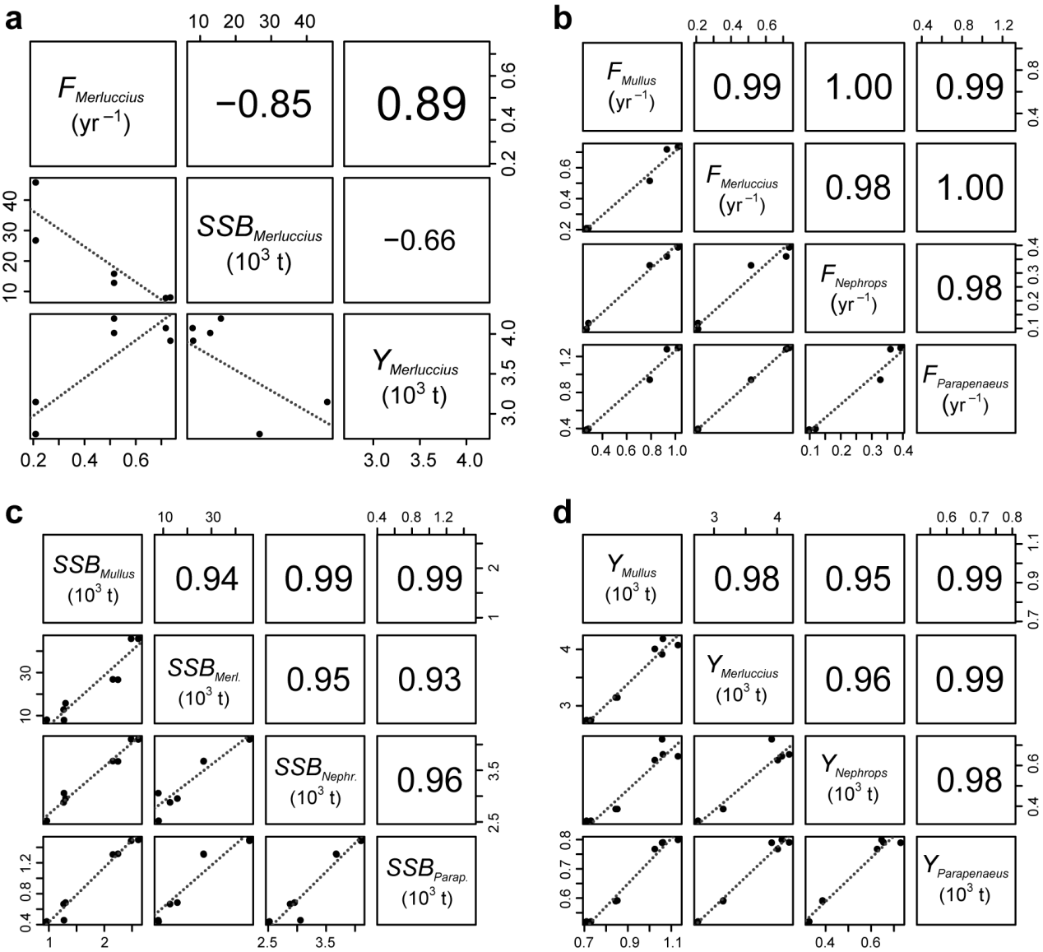

Fig. S1. Correlation among biological indicators (*F*, *SSB* and *Y*) for the GSA 18 case study. *a*: correlation among biological indicators for *M. merluccius* (results are shown only for the most vulnerable species, but are representative of the other species too). *b*–*d*: correlation among fishing mortality rate (*b*), spawning stock biomass (*c*) and fishing yield (*d*) for the four target species.

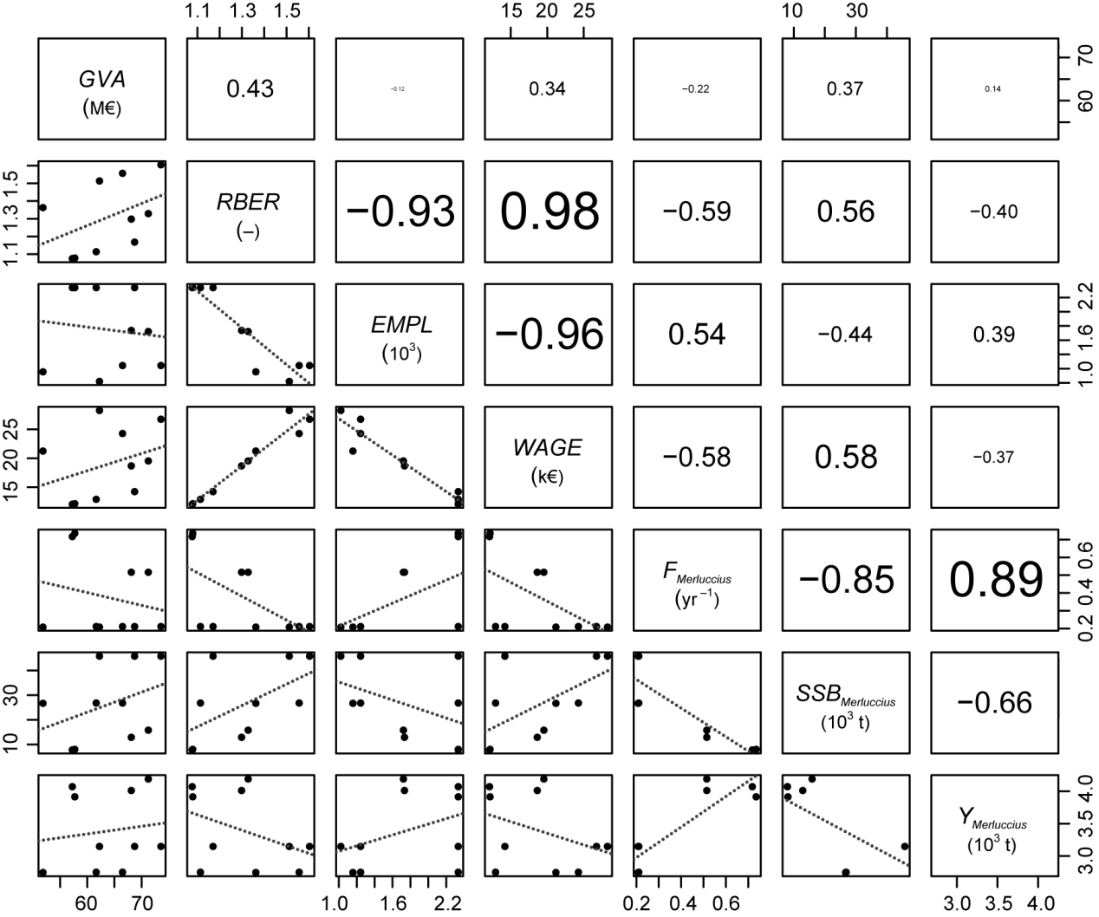

Fig. S2. Correlation across socioeconomic (*GVA*, *RBER*, *EMPL* and *WAGE*) and biological (*F*, *SSB* and *Y*) indicator values for the GSA 18 case study. For the sake of convenience, biological indicators are shown only for *M. merluccius*, but are representative of the other species too.

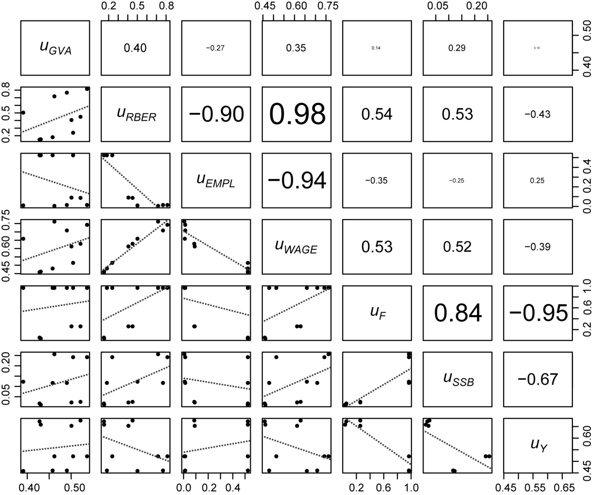

Fig. S3.Correlation among partial utilities associated with the different socioeconomic (*GVA*, *RBER*, *EMPL* and *WAGE*) and biological (*F*, *SSB* and *Y*) indicators considered in the multi-criteria analysis for the GSA 18 case study. Utility values for biological indicators combine the results for all target species.